COURSE DESIGN

Table of Contents
Introduction 3
Course Design Template 4
Learning Goals 4
Design and Structure: Topics 5
Design and Structure: Order 6
Design and Structure: Sequence of Topics 6
Learning Activities and Instructional Strategies 8
Learning Activities and Instructional Strategies: Materials 9
Alignment 10
Syllabus 11
Assessment 16
Twelve assessment techniques 16
Aligning Learning Objectives and Types of Assessment 18
Sample Rubrics 20
Common Grading Practices at Haas 22
Berkeley – Hass Grading Guidelines 22

Introduction
This handout provides supporting material for the Course Design workshop offered by the Center for Teaching Excellence. Student – centered teaching motivates the recommendations for instructors designing a new course or redesigning an existing one. The framework for student centered course design, covered in the Course Design and Structure, shapes the flow of the following material.

Student-centered course design

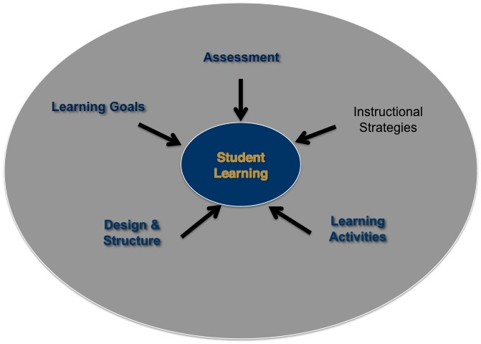

Course Design Template

Learning Goals

Use the space below to list your initial Learning Goals. Consider the following questions as you develop your list.
- What are the BIG questions that your discipline hopes to answer?
- Who are your students? What do your students need to learn? What are they prepared to learn?
- What subject matter (or content) goals are needed for these students? E.g. discipline specific knowledge, tools, framework
- What content-neutral outcomes are needed for these students? E.g. higher order thinking skills, attitudes or self-awareness

Learning objectives:

1.__________________________________________________________________________________________________________________________________________

- ________________________________________________________________________________________________________________________________________

3.__________________________________________________________________________________________________________________________________________

4.__________________________________________________________________________________________________________________________________________

5._________________________________________________________________________________________________________________________________________

Design and Structure: Topics

Use the space below to brainstorm:
What specific topics will you cover in this class to achieve your learning objectives?
Pare the content list down to 4-7 topics:

1.

2.

3.

4.

5.

6.

7.

Design and Structure: Order

The order of the course provides a narrative or organizing framework for your students. The materials and instructional strategies that you use support the course narrative for your students.

Draw a diagram representing your course.
Here are some ideas:
- Does the course move from macro to micro or the reverse - draw a hierarchy.
- Does the course follow a distinct path? Try stepping stones.
- Is there a central idea (in a circle) with related topics radiating outward?

Design and Structure: Sequence of Topics
The sequence of topics is the manifestation of the structure and order of course topics. Based on the topics that you’ve identified and their order, lay them out in the table below. What topics need to come first? How many class sessions will it take to cover each topic? How will the course end?

You may need to do this several times to pare all the content down into one semester. Courses at Haas are typically 7 weeks, 14 weeks (undergraduates) or 15 weeks.

Week’s topic | Class sub-topic | Class sub-topic
1
2
3
4
5
6
7
8
9
10
11
12
13
14
15

Learning Activities and Instructional Strategies
- Cases
- Readings
- Interactive Discussions
- Simulations
- Debates

- Guest speakers
- Lecture
- Discussion board
- Presentations
- Think-pair-share

- Homework problems
- Essays
- Research
- Reflection papers
- Hands-on demonstrations
Above is a sample of instructional strategies and learning activities you might employ to deliver your course.
- Notice some of these strategies are assessments as well (See the section of this handout about assessments and grading for more explanation about assessments).
- You will need a variety of learning activities and instructional strategies to communicate the basic concepts and to require higher order thinking from your students.

Learning Activities and Instructional Strategies: Materials

You are now ready think about the specific materials for the course. List the types of materials you would like to use to support the course content and structure e.g., textbooks, articles, video, online content.

Once you have found the specific materials (e.g. exactly which textbook, cases or articles you will assign), you will be ready to align the different elements of your course.

Alignment
Learning Goals - Topics – Order - Instructional strategies – Learning Activities
Complete the following table to plan the main components of your course and to ensure coherence among the different elements. Verify that there is balance, rigor and a close alignment between the Learning Objectives, the Topics, the Structure, the Instructional Strategies, Learning Activities and Assessments.

Learning Objectives | Topics | Instructional strategy/Activity | Assessment
Students will be able to accurately communicate statistical concepts | Data collection and experimental design  Std deviation & variability  Data description | Textbook  In-class: graphing calculator exercise, data collection exercise, case discussion about variability | 1. Helicopter experiment - group write-up  2. Pre-election poll - individual report  3. Excel lab #5

Syllabus
On the following pages is an exhaustive list of possible elements to include in a syllabus. The Center for Teaching Excellence also has sample syllabi for you to use.

Helpful reminders:
- The syllabus is a form of learning contract.
- The syllabus is a resource that can pique students’ interest
- Including more rather than less reduces anxiety and can be a learning tool.
- End the syllabus on a positive upbeat note.

Checklist: Components of a Comprehensive Course Syllabus
From Tools for Teaching (2009) by Barbara Gross Davis

Basic Information Course Description Materials

- Name of university, semester, year
- Course title, number, unit value
- Course meeting times and location
- Instructor, GSI names
- How to contact instructor/GSIs:
  - In-person office hours: times and location (with map if needed); drop-in or by appointment?
  - Online office hours: times and how to access (URL)
  - Email addresses
  - Phone numbers: private office and department lines; mobile, if you wish, for text messages
  - Preferred mode of communication (email, phone, text messages, in person, instant message, throught learning management system, through social networking site, etc)
  - Fax number
  - Optional: times other than office hours when instructor can be reached
- Instructor Web page URL
- Course Web page URL
- Online chat days, hours, and access address, if available
- Group mail-list address, if available

- Prerequisites
  - Prior courses
  - Knowledge/skills needed to succeed in this course
  - Permission of instructor needed?
- Technology requirements:
  - Laptops for class work
  - Software
  - Clickers
  - Learning management system
- Overview of course:
  - What is the course about: its purpose, rationale?
  - What are the general topics or focus?
  - How does it fit with other courses in the department or on campus?
  - Who is the course aimed at?
  - Why would students want to take this course and learn this material?
- Student learning objectives:
  - What will students be expected to know or do after this course?
  - What competencies/skills/ knowledge will student be expected to demonstrate at the end of the course?
- Methods of instruction
  - Lecture
  - Discussion
  - Group work
  - Field work
  - Other methods
- Workload
  - Estimated amount of time to spend on course readings
  - Estimate amount of time to spend on course assignments and projects

- Primary or required books/readings for the course:
  - Author, title, edition ISBN
  - Costs, where available
  - Availability of electronic or alternative formats, for students with disabilities
- Supplemental or optional books/readings
- Websites and links
- Other materials:
  - Lab equipment
  - Art supplies
  - Software
  - Other types of materials

Requirements

- Exams and quizzes:
  - How many
  - What kind (e.g. open/closed book; essay/multiple choice)
  - Knowledge and abilities tested
  - Place, date, and time of finals exam
- Assignments/problem sets projects/reports/research papers:
  - General information on type, length, and when due (detailed information can be distributed during the term)
  - Relationship between the learning objectives and assignments
  - Criteria for assessing student work
  - Format for submitting work (online or in hard copy)
  - For research papers and projects:
    - Steps in conducting research
    - Shorter assignments that build to the research paper (e.g. annotated bibliography of primary sources, thesis statement, fact sheet, etc.)
    - Skills and knowledge students need to complete the assignment
    - Connection between research assignments and course goals and student learning objectives
- Other requirements:
  - Attend an office hour?
  - Post comments to the discussion board?

Policies

- Grading procedures:
  - Describe how students will be graded: on a curve or absolute scale?
  - Clarify weighting of course components
  - Explain policies regarding incompletes, ass/not pass
  - Describe grade appeals
- Attendance and tardiness
- Class participation
- Classroom decorum
- Interrupted exams (e.g. fire alarms)
- Missed exams/makeup exams
- Missed assignments
- Late assignments/extensions
- Reporting illness and family emergencies
- Extra credit opportunities
- Permissible and impermissible collaboration
- Standards for academic honesty and penalties for infractions

Schedule

- Tentative calendar of topics and readings:
  - By week rather than by session
  - Or leave some sessions empty for flexibility
- Firm dates for exams and written assignments
- Dates of special events:
  - Field trips
  - Performances
  - Exhibits
  - Other special events
- Last day to switch to pass/not pass
- Last day to withdraw from the course

Resources

- Tips for success
  - How students might approach the material
  - How students can manage their time
  - Tips for studying, taking notes, preparing for exams
  - Common students mistakes or misconceptions
- Copies of past exams or model student papers
- Glossaries of technical terms
- Links to appropriate support material on the Web (e.g. style manuals, past students’ projects, Web-based resources, etc.)
- Academic support services on campus
- Information on the availability of podcasts or webcasts
- Space for students to identify two or three classmates’ names and their contact information
  - In case they miss class
  - To form a study group

Statement on Accommodation

- A request that students see the instructor to discuss accommodations for:
  - Physical disabilities
  - Medical disabilities
  - Learning disabilities
- A statement on reasonable accommodation for students’ religious beliefs, observations, and practices; for students’ foreseeable conflicts because of athletic competition, medical/graduate school interviews

Evaluation of the Course and Assessment of Student learning

- Student feedback strategies during the semester (other than quizzes and tests)
- End-of-course evaluation procedures

Rights and Responsibilities

- Students’ and instructor’s rights to academic freedom (e.g. respect of the rights of others to express their points of view)\
- Students’ and instructor’s adherence to campus principles of community (e.g. civility in personal interactions)
- Statement on copyright protection for the contents of the course, as appropriate

Safety and Emergency Preparedness

- What to do in case of an earthquake, fire, hazardous spill, accident or injury, bomb threat, or other emergency
- Notification procedures for inclement weather
- Evacuation procedures
- Lab safety precautions

Disclaimer

- Syllabus/schedule subject to change

Assessment

Twelve assessment techniques

- Applications cards - Identify a concept or principle your students are studying and ask students to come up with 1-3 applications of the principle from everyday experience, current news events, or their knowledge of particular organizations or systems discussed in the course.

- Analytic Memos - Ask students to write a one- or two-page analysis of a specific problem or issue. The person to whom the memo is written is usually identified as an employer, a client, or stakeholder who needs the analysis to make an informed decision. (Be explicit about the setting, the person, the purpose and the subject.) Students can work individually, in pairs, or small groups. Feedback should be based on 3-5 major points, using a rubric.

- Concept Maps - Concept maps are diagrams showing connections between a focal topic and other concepts learned. The main concept is in the center with connections drawn to other concepts above, below, to the side. To begin, show students a concept map that you have drawn. Discuss the main idea and connecting concepts that you have included. Next, prompt students to make a concept map beginning with the central concept (e.g. diffusion of knowledge) in the center of a blank sheet of paper. Ask them to add in other ideas (e.g. learning, delivery, action, storytelling) or concepts that come to mind. Collect the sheets anonymously. Reviewing the students’ concept maps reveals the depth of understanding that students have about course topics and how they are thinking about them.
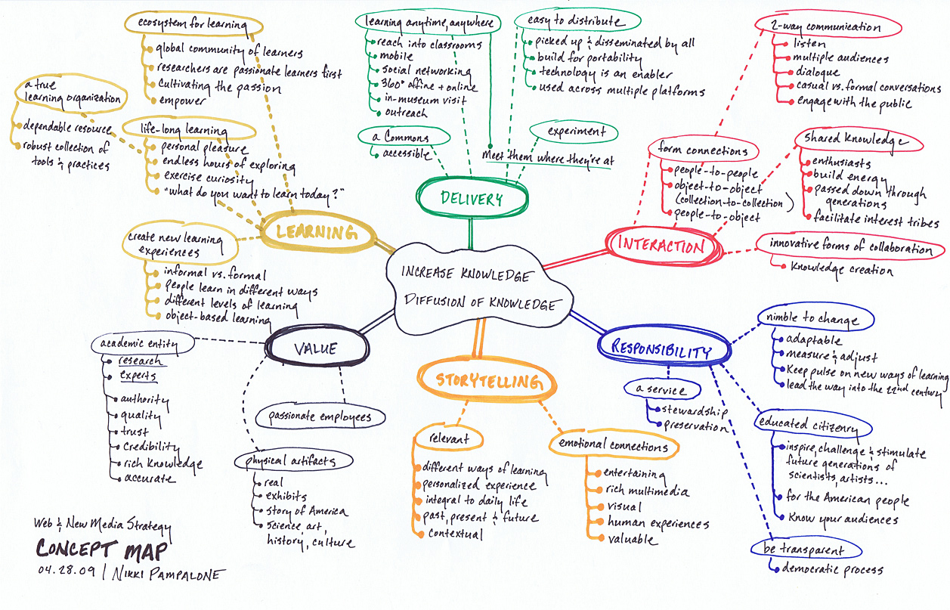
Options :
  - Create a concept map with some of the concepts missing. Provide a list for student to use to fill-in the missing concepts.
  - Repeat the concept map assignment later in the term to observe the development of student thinking.
  - Ask students to write an explanatory essay based on their maps.

- Dynamic list of questions - As a homework assignment, ask students to write a list of questions that they hope to answer by the end of the class period. During class they cross off questions as they are answered and add questions as new ones arise. At the end of class, collect the lists for a snapshot of preparation, learning and unanswered questions.

- Word Journal - Requires a two-part response. Firstly, students summarize a short text with a single word. Next students write a paragraph or two explaining why they chose that particular word to summarize the text. The complete word journal entry is an abstract or synopsis of the focus text.

- Empty outline - The instructor distributes an empty or partially completed outline either as an in-class presentation or a homework assignment. Students should have a limited amount of time to complete the missing information. Can be used at the conclusion of a class or the beginning of the next one. If the course is too large to provide individual feedback, this technique can be assigned to groups or to generate class discussion.

- Muddiest point - Similar to the Minute Paper, ask your students to answer: “What was the muddiest point in… (today’s lecture, the reading, the homework)?” Students need to identify fairly quickly (in 1-2 minutes) what they do not understand and submit it on an index card.

- One-minute paper - Pose 1-2 questions in which students identify the most significant things they have learned from a given lecture, discussion or assignment e.g. “What was the most important thing that you learned today?” The question can be very general or content specific. For example, “What question is upper most in your mind at the end of today’s class?” Their answers help you to determine if they are successfully identifying what you view as most important. Give students about 1-2 minutes and ask them to write a response on an index card, or no longer than a half page.

- Online polling - Post multiple-choice questions about key concepts on the course website. Students can select the best answer. Once they submit their answer they can view a summary graph of the class results. Share correct answers in the next class session. Students can receive credit for responding, but responses are not graded.

- Online reactions - Ask students to post their reactions to that days lecture or class discussion on a discussion board. Comments should be anonymous. Online questions can ask students to rate how challenging the topic was, to indicate an important point or identify and hard-to-follow portion of the class session.

- Think-pair-share - Pose a question, and ask student to consider the question, jotting down a few ideas, and then turn to a neighbor and share their thoughts. Next the pairs report their discussion to other pairs and, as size and time permits, to the class.

- What’s the principle? - Provide students with a few problems/examples and ask them to state the principle that best applies to the problem.

Aligning Learning Objectives and Types of Assessment

Types of Learning Objective | Types of Assessment | How to Measure
Remember  Students will be able to:  - recall  - recognize | Test items that require students to recall or recognize information:  - Fill-in the Blank  - Multiple Choice questions such as, “what is a…”, or “which of the following is the definition...  - Labeling diagrams  - Reciting (orally, or in writing) | Accuracy – correct vs number of errors  Item Analysis (at the class level, are there items that had higher error rates? Did some items result in the same errors?)
Understand  Students will be able to:  - interpret  - exemplify  - classify  - summarize  - infer  - compare  - explain | Papers, oral/written exam questions, problems, class discussions, concept maps, homework assignments that require (oral or written):  - Summarizing readings, video, etc.  - Comparing and/or contrasting two or more theories, events, etc.  - Classifying or categorizing cases, elements, processes, etc., using established criteria  - Paraphrasing documents or  - Finding or identifying examples or illustrations of a concept, principle | Scoring rubrics that identify critical components of the work and discriminate between differing levels of proficiency in addressing the components
Apply  Students will be able to:  - execute  - implement | Activities that require students to use procedures to solve or complete familiar or unfamiliar tasks; may require students to determine which procedure(s) are most appropriate for a given task. Activities include: Problem sets, labs, prototyping, simulations | Accuracy scores, Check lists, and Rubrics
Analyze  Students will be able to:  - differentiate  - organize  - attribute | Activities that require students to discriminate or select relevant from irrelevant parts, determine how elements function together, or determine bias, values or assumptions in materials. These might include:  Case studies, Critiques, Labs, Papers, Projects, Debates, Concept Maps. | Rubrics, scored by instructor, juries, external clients, employers, internship supervisor, etc.
Evaluate  Students will be able to:  - check  - critique | A range of activities that require students to test, monitor, judge or critique readings, videos, or products against established criteria or standards. These activities might include:  Journals, Diaries, Critiques, Problem Sets, Product Reviews, Case Studies. | Rubrics, scored by instructor, juries, external clients, employers, internship supervisor, etc.
Create  Students will be able to:  - generate  - plan  - produce | Research projects, essays, business plans, website designs, prototyping, portfolios. | Rubrics, scored by instructor, juries, external clients, employers, internship supervisor, etc.

Sample Rubrics

For written cases analyses
Criteria | A | B | C | D
Arguments | Paper has clear, strong arguments that go beyond description | Paper has discernible arguments but may be somewhat unclear or weak | Paper has arguments but often falls into description | Paper has few or no arguments, spends most time describing
Support | Numerous, varied and relevant details and facts support arguments | Details and facts support arguments, but may not provide enough or may be as relevant as possible | Some details and facts to support arguments, but not enough and some lack relevancy | Few or no relevant details and facts to support arguments
Use of course concepts | Demonstrates excellent understanding of course concepts and applies them correctly | Conveys course concepts adequately but fails to elaborate | Correctly grasps basic concepts but cannot apply to situation appropriately | Basic course concept(s) is wrong, incorrect, or substantially incomplete
Originality | Demonstrates excellent analytical originality, either in creating new arguments or in relating facts in new ways (beyond what is suggested by sources) | Demonstrates some, but not a great deal of, analytical originality, either in creating new arguments or in relating facts in new ways | Demonstrates little analytical originality, relies mainly on arguments and evidence already covered in class or suggested by case or other sources | Makes no attempt to provide original analysis
Organization | Clear organization that walks the reader through the paper, does not stray off topic | Clear organization but strays slightly | Organization is less than clear, or organization is clear but some digressions | Organization is unclear and/or paper strays substantially from topic
Level of discourse | Variety of sentence structures, good use of cohesive devices, e.g. transitions | Some variety in sentence structure, adequate use of cohesive devices | Limited variety in sentence structure, little use of cohesive devices | Mostly single- clause sentences, little to no use of cohesive devices
Grammar | No major errors, a few minor errors that do not distract | One major error or several minor errors that do not distract | Two or three major errors combined with minor errors | Numerous major errors
Vocabulary | Precise diction, rich use of appropriate vocabulary | Generally good vocabulary choices with some variety, minor errors in diction | Limited vocabulary, not always precise or accurate | Incorrect use of vocabulary, very limited range

Class participation/contribution rubric

1 point - Has read the case and other reading materials and is somewhat aware of the issues.

2 points - Has prepared the case thoroughly and dug deeper and grasped the main points and key issues in the case.

3 points - By extensive preparation has analyzed the case fully and lucidly expounded analyses and proffered cogent recommendations and overall has contributed substantially to class learning.

4 points - Through extensive preparation has been able to build frameworks and managerial learnings by linking case analyses and learnings from previous cases with the current case, contributed very substantially to class learning, and steered class discussion to areas providing additional learning.

5 points - Contributed extremely to class learning and taught the faculty something about the case.

Common Grading Practices at Haas

The following is a list of frequently-used graded assignments. Depending on the discipline and instructor preference, different weights are assigned to different assignments.

- Homework problem sets
- Multiple choice and matching tests/quizzes
- Problem set tests
- Short answer and essay tests
- Written case analyses (in-class and take home)
- Presentations (individual and group)
- Research projects (individual and group)
- Participation

Berkeley – Hass Grading Guidelines

Available online at https://groups.haas.berkeley.edu/AcademicAffairs/Bylaws/documents/Policy%20on%20Grading.pdf

POLICY OF THE HAAS SCHOOL OF BUSINESS
WITH RESPECT TO GRADING
(Adopted by the Faculty April 29, 2011)

The Haas School seeks to assign grades that reflect students’ performance, in accordance with UC Berkeley’s grading policy, which states:

“The work of all students on the Berkeley campus is reported in terms of the following grades: A (excellent), B (good), C (fair), D (barely passing), F (failure), P (passed at a minimum level of C-), NP (not passed), S (satisfactory, passed at a minimum level of B-), U (unsatisfactory), I (work incomplete due to circumstances beyond the student's control, but of passing quality), IP (work in progress; final grade to be assigned upon completion of entire course sequence). The grades A, B, C, and D may be modified by plus (+) or minus (-) suffixes.” (http://berkeley.edu/catalog/policies/grades.html)

The Haas School policy with respect to grading has three goals: to ensure that grading is fair across courses; to encourage students to take their coursework seriously; to hold faculty accountable to the rigorous standards of the Haas School of Business. All instructors who teach Undergraduate, Full Time MBA, Evening and Weekend MBA, Berkeley-Columbia Executive MBA, or MFE courses will be required to follow this grading policy. Only PhD courses are exempt.

Mean Course GPA Requirements for Electives

As with all UC Berkeley courses, letter grades are assigned a point value as follows:
A+ = A = 4.0; A– = 3.7; B+ = 3.3; B = 3.0; B– = 2.7; C+ = 2.3; C = 2.0; C– = 1.7;
D+ = 1.3; D = 1.0; D– = 0.7; and F = none.

When assigning grades to an elective (non-core) course, the mean GPA in any class with enrollments of 18 or more students should be no more 3.4.

For elective classes with enrollments of fewer than 18 students, an instructor who wishes to violate this policy must explain in writing to the ADI why the course, and the distribution of students who are enrolled, warrant a deviation from this policy. Written approval from the Senior Assistant Dean of Instruction (SADI) must be obtained to proceed with a different mean GPA for the class. In the event of such an approved deviation from the policy, the mean GPA of any course should not exceed 3.65.

For elective classes with enrollments of 18 or more students, the process for obtaining an approved deviation from this policy will require not only the SADI’s approval as described above, but will also require written approval from the Dean of the Haas School.

Distribution Requirements for Core Courses

Core courses must be graded along a curve that is stricter than the mean GPA cap of 3.4. The following grade distributions should be followed as closely as possible given the number of students enrolled in the class.
Core courses in the undergraduate program must adhere to the following distribution: 10% A; 15% A-; 20% B+; 25% B; 15% B-; 10% C+; 5% C or below. This curve implements a mean GPA of roughly 3.12 or less.

Core courses in all the Masters programs must adhere to the following distribution: 15% A; 20% A-; 30% B+; 20% B; and 15% B- or below. This curve implements a mean GPA of roughly 3.3 or less.

Monitoring and Reporting

After grades are assigned the SADI’s office will calculate the mean GPA of all courses and the distributions of grades for all core courses. Instructors whose grade assignments violate this policy will be promptly notified by the SADI and asked to immediately amend their assigned grades to satisfy this policy’s requirements.

Enforcement and Consequences

If for any reason a grade assignment that violates this policy is not corrected, the SADI will report such violations to all the Haas instructors, to the ADAA and to the Dean via an email that lists the violators, their courses, and the complete grade distribution of their course. If any of the violations was for a class of less than 18 students, and was approved by the SADI, the SADI will include in the email the reasons for the exceptional approval.

Group Chairs and the SADI are responsible for communicating the importance of this policy to all Haas instructors. Group Chairs and the ADAA will consider any such violations when making non-ladder appointments or reappointments, and when discussing teaching in ladder merit cases. The SADI will inform non-ladder faculty that violations of this policy may result in a termination of their teaching for the Haas School of Business.

Available online at https://groups.haas.berkeley.edu/AcademicAffairs/Bylaws/documents/Policy%20on%20Grading.pdf

